
Touchstones
Netcards

Generosity Netcards with Text

Anne Frank HRJ
Barbed Wire HRJ
Begin HRJ
Black and White HRJ

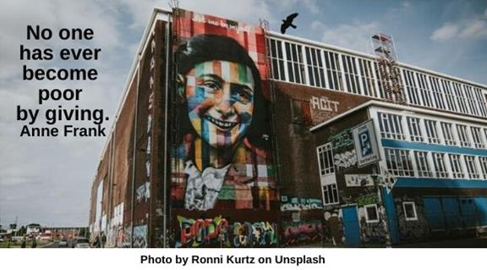

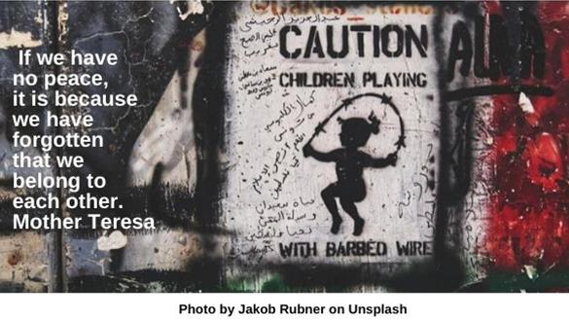

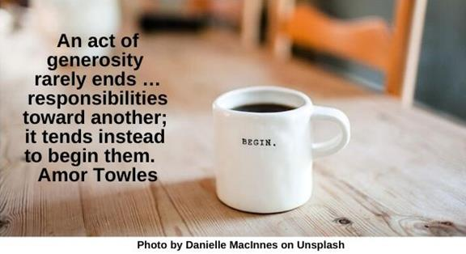


Candle HRJ
Children Walking HRJ
Connections HRJ
Dalai Lama HRJ

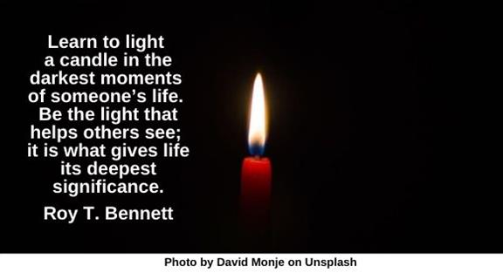

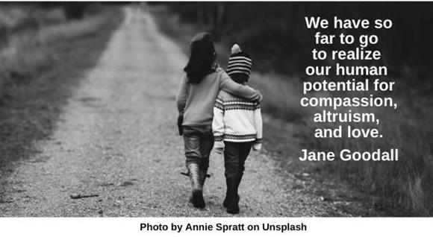

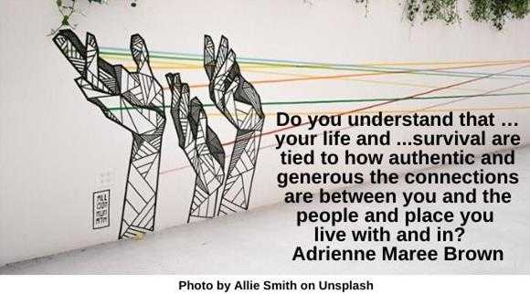

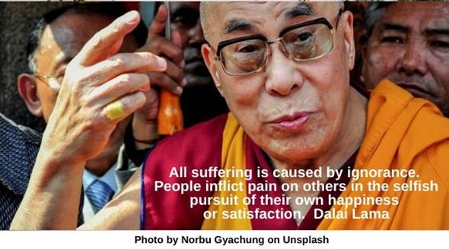

Earth HRJ
Embrace HRJ
Fingers HRJ
Fred Rogers HRJ

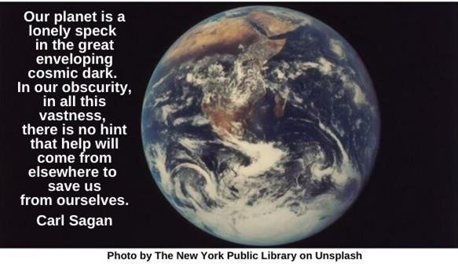

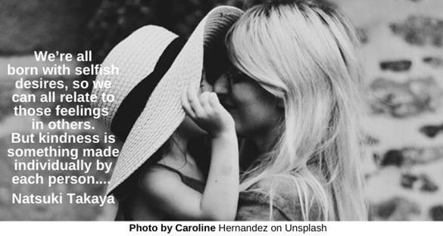

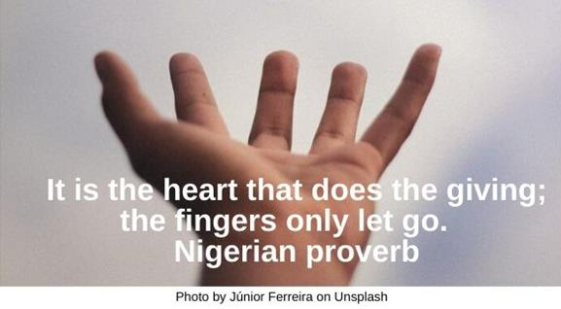

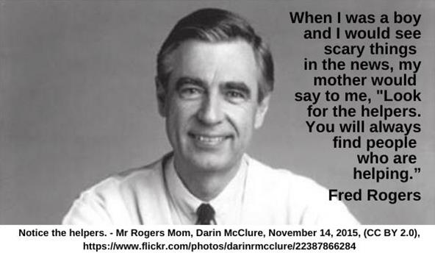

Future HRJ
Garbage Dump HRJ
I Voted Sticker HRJ
Kindergarten HRJ

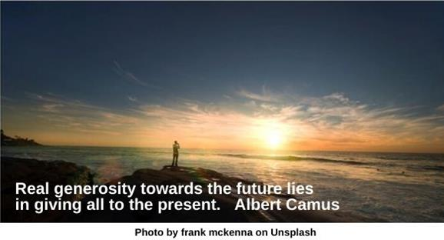

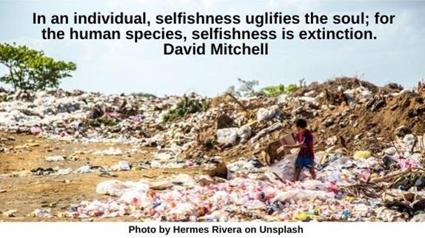



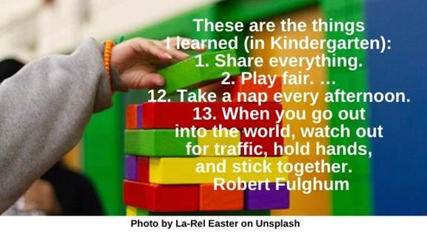

Love HRJ
Mandela HRJ
No Mean People HRJ
Nothing HRJ

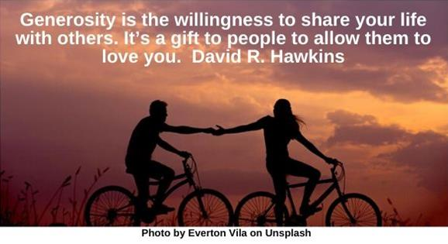

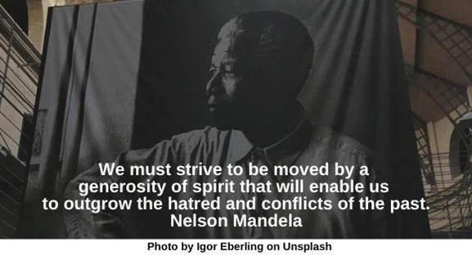

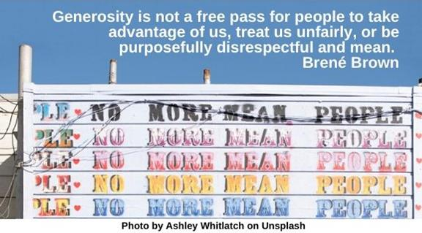

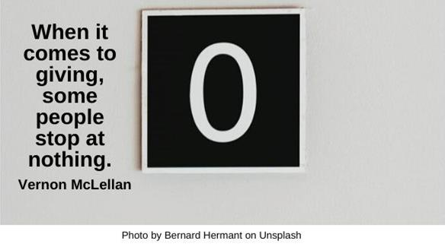

Orchestra HRJ
Piggy Bank HRJ
Plum Tree HRJ
Soil HRJ

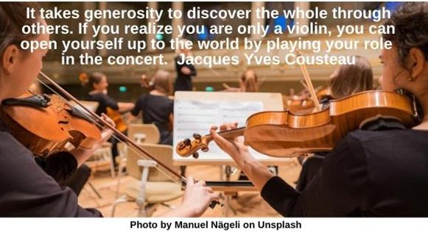

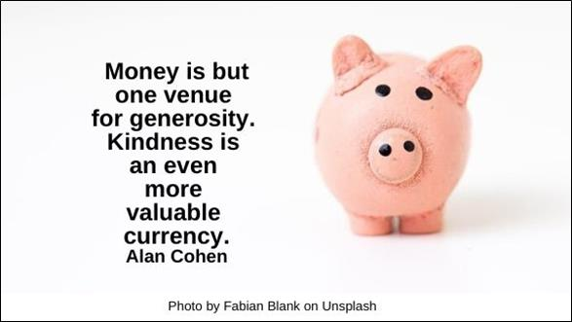



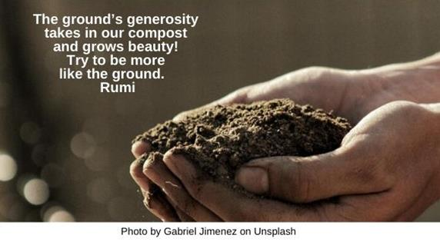

Stuffed Bear HRJ
Taxes HRJ
Teacher HRJ
Tornado HRJ

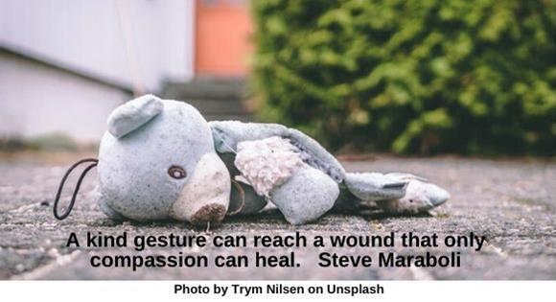



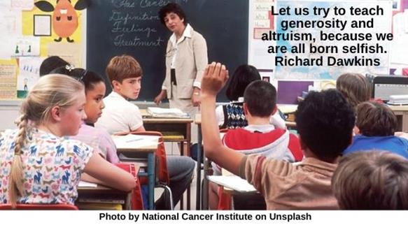

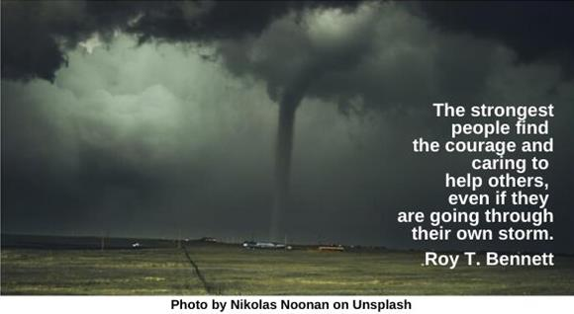

Trees HRJ
Vulnerability HRJ
Winter Sky HRJ
World HRJ

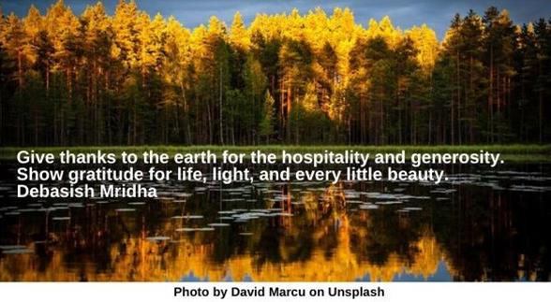

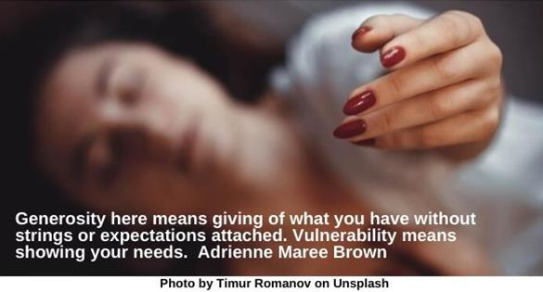

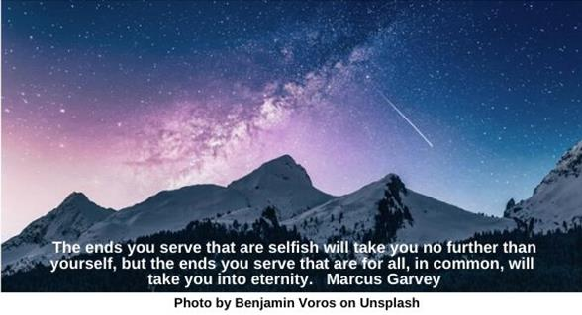

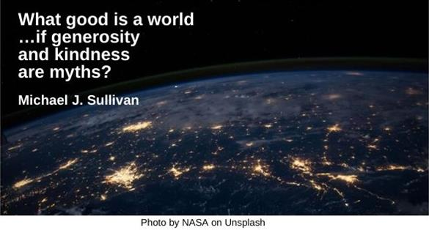

Text of Quotes

Anne Frank
No one has ever become poor by giving. Anne Frank

Barbed Wire
If we have no peace, it is because we have forgotten that we belong to each other. Mother Teresa

Begin
An act of generosity rarely ends …responsibilities toward another; it tends instead to begin them. Amor Towles

Black and White
“Every[one] …must decide whether… [they] will walk in the light of creative altruism or in the darkness of destructive selfishness.” Martin Luther King, Jr.

Candle
Learn to light a candle in the darkest moments of someone’s life. Be the light that helps others see; it is what gives life its deepest significance. Roy T. Bennett

Children Walking
“We have so far to go to realize our human potential for compassion, altruism, and love.” Jane Goodall

Connections
Do you understand that …life and your survival are tied to how authentic and generous the connections are between you and the people and place you live with and in? Adrienne Maree Brown

Dalai Lama
All suffering is caused by ignorance. People inflict pain on others in the selfish pursuit of their own happiness or satisfaction. Dalai Lama

Earth
Our planet is a lonely speck in the great enveloping cosmic dark. In our obscurity, in all this vastness, there is no hint that help will come from elsewhere to save us from ourselves. Carl Sagan

Embrace
We’re all born with selfish desires, so we can all relate to those feelings in others. But kindness is something made individually by each person.... Natsuki Takaya

Fingers
It is the heart that does the giving; the fingers only let go. Nigerian proverb

Fred Rogers
When I was a boy and I would see scary things in the news, my mother would say to me, “Look for the helpers. You will always find people who are helping.” Fred Rogers

Future
Real generosity towards the future lies in giving all to the present. Albert Camus

Garbage Dump
In an individual, selfishness uglifies the soul; for the human species, selfishness is extinction. David Mitchell

I Voted Sticker
If you have selfish, ignorant citizens, you're going to get selfish, ignorant leaders. George Carlin

Kindergarten
These are the things I learned (in Kindergarten): 1. Share everything. 2. Play fair. … 12. Take a nap every afternoon. 13. When you go out into the world, watch out for traffic, hold hands, and stick together. Robert Fulghum

Love
Generosity is the willingness to share your life with others. It’s a gift to people to allow them to love you. David R. Hawkins

Mandela

We must strive to be moved by a generosity of spirit that will enable us to outgrow the hatred and conflicts of the past. Nelson Mandela

No Mean People
Generosity is not a free pass for people to take advantage of us, treat us unfairly, or be purposefully disrespectful and mean. Brené Brown

Nothing
When it comes to giving, some people stop at nothing. Vernon McLellan

Orchestra
It takes generosity to discover the whole through others. If you realize you are only a violin, you can open yourself up to the world by playing your role in the concert. Jacques Yves Cousteau

Piggy Bank
Money is but one venue for generosity. Kindness is an even more valuable currency. Alan Cohen

Plumtree
Don't touch my plumtree!
Said my friend and saying so...
Broke the branch for me
Taigi

Soil
The ground’s generosity takes in our compost and grows beauty! Try to be more like the ground. Rumi

Stuffed Bear
A kind gesture can reach a wound that only compassion can heal. Steve Maraboli

Taxes
Generosity is not always tax deductible. Ken Solts

Teacher
Let us try to teach generosity and altruism, because we are all born selfish. Richard Dawkins

Tornado
The strongest people find the courage and caring to help others, even if they are going through their own storm. Roy T. Bennett

Trees
Give thanks to the earth for the hospitality and generosity. Show gratitude for life, light and every little beauty. Debasish Mridha

Vulnerability
Generosity here means giving of what you have without strings or expectations attached. Vulnerability means showing your needs. Adrienne Maree Brown

Winter Sky
The ends you serve that are selfish will take you no further than yourself but the ends you serve that are for all, in common, will take you into eternity. Marcus Garvey

World
What good is a world …if generosity and kindness are myths? Michael J. Sullivan

